**“Experiment 1.4”**

Student Name: **SUMIT KUMAR** UID: **20BCS8226**

Branch: **CSE** Section/Group: **808 A**

Semester: **5** Date of Performance: **18-08-22**

Subject Name: **Multimedia Technologies Lab**  Subject Code: **20CSP-339**

**1. Aim/Overview of the practical:**

Convert the given image to a pencil sketch.

**2. Which logistics used:**

Hardware Requirements: - Minimum 384MB RAM, 100 GB hard Disk, processor with 2.1 MHz

Software Requirements: - Photopea

Tools Used: - Type Tool, Bevel and Emboss, Emboss option

**3. Steps for experiment/practical/Code:**

**Step 1:** Create new project on Photopea, and specify dimensions as required.

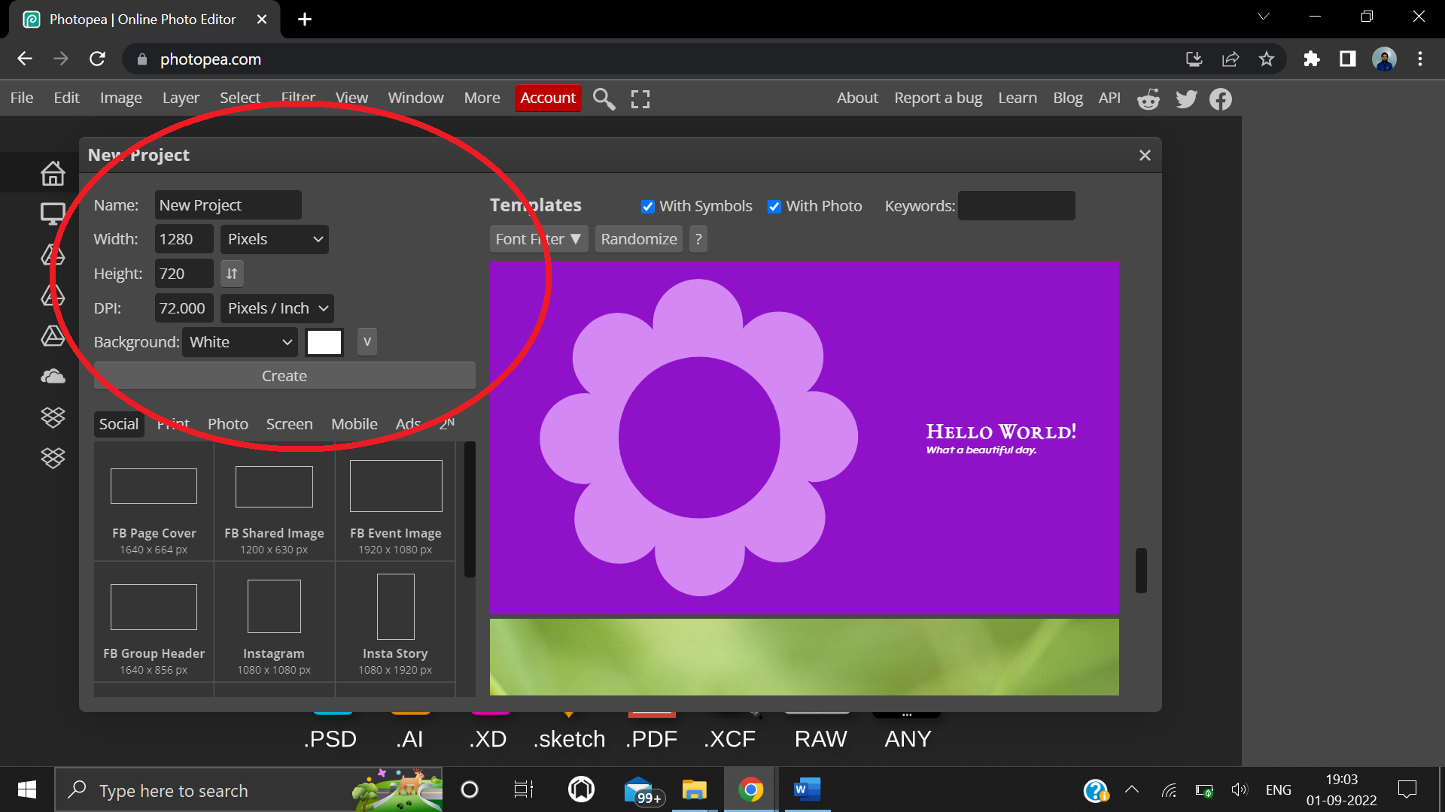

**Step 2:** Select a real life image to convert into a pencil sketch.

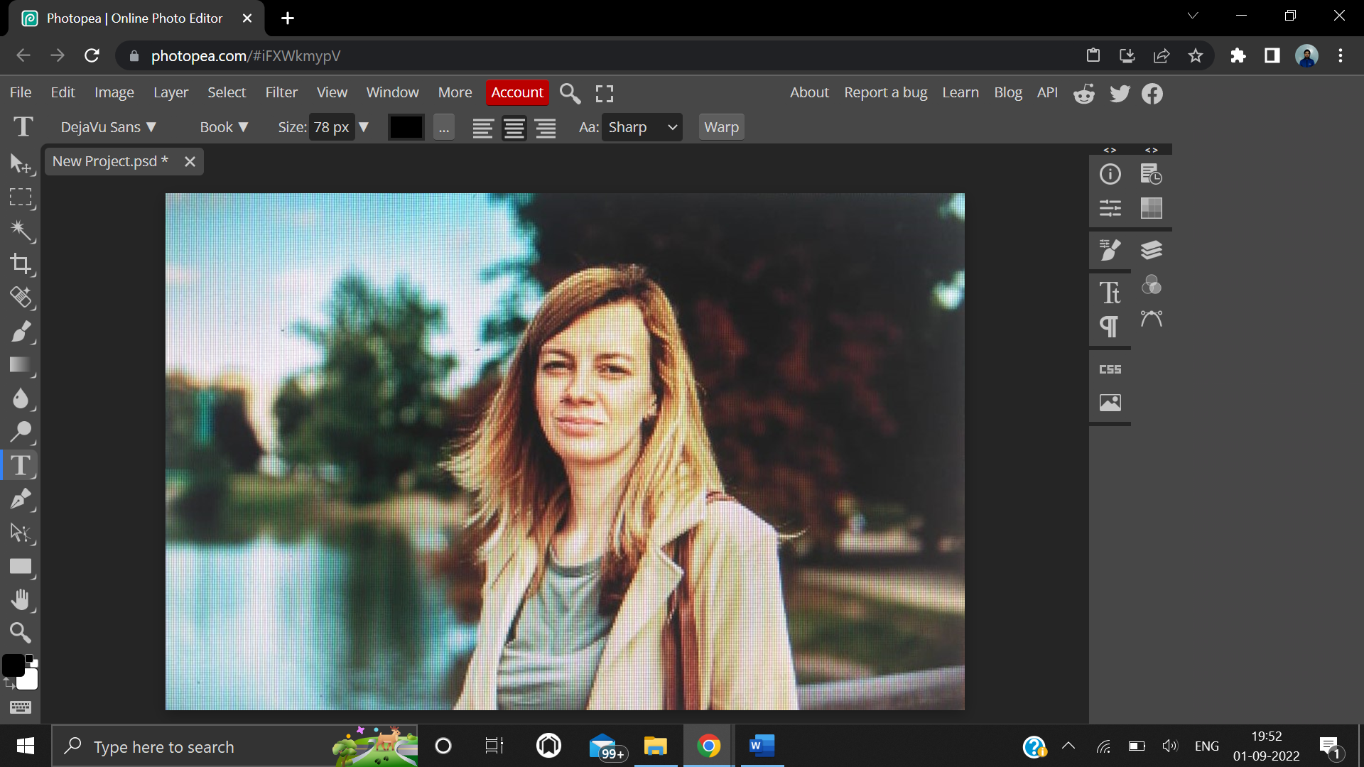

**Step 3:** From the top navbar, click Select, and select Magic Cut from the dropdown menu to remove the background from the photo.

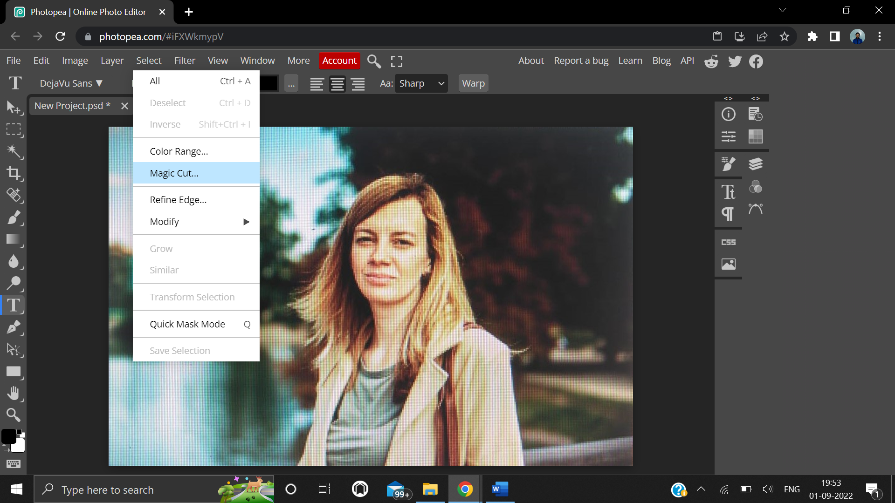

**Step 4:** From layer on top navbar, and new white color fill layer above the Magic Cut layer to make the background white.

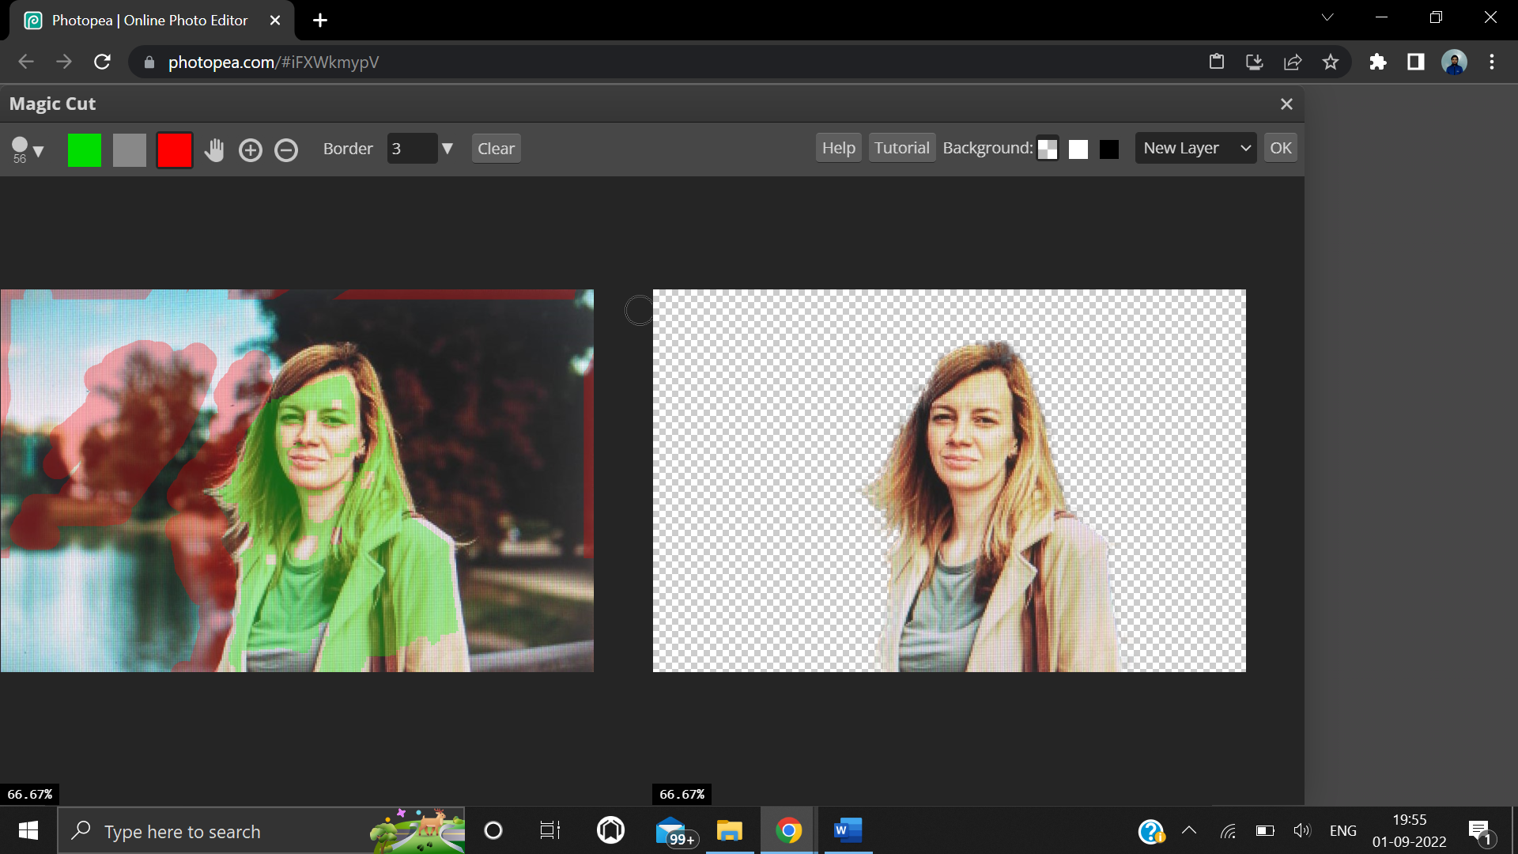

**Step 5:** Duplicate the Magic Cut layer and convert it into smart object by right clicking on that layer on the layer menu in the right of the screen, and selecting the duplicate and convert into smart object options from the dropdown menu.

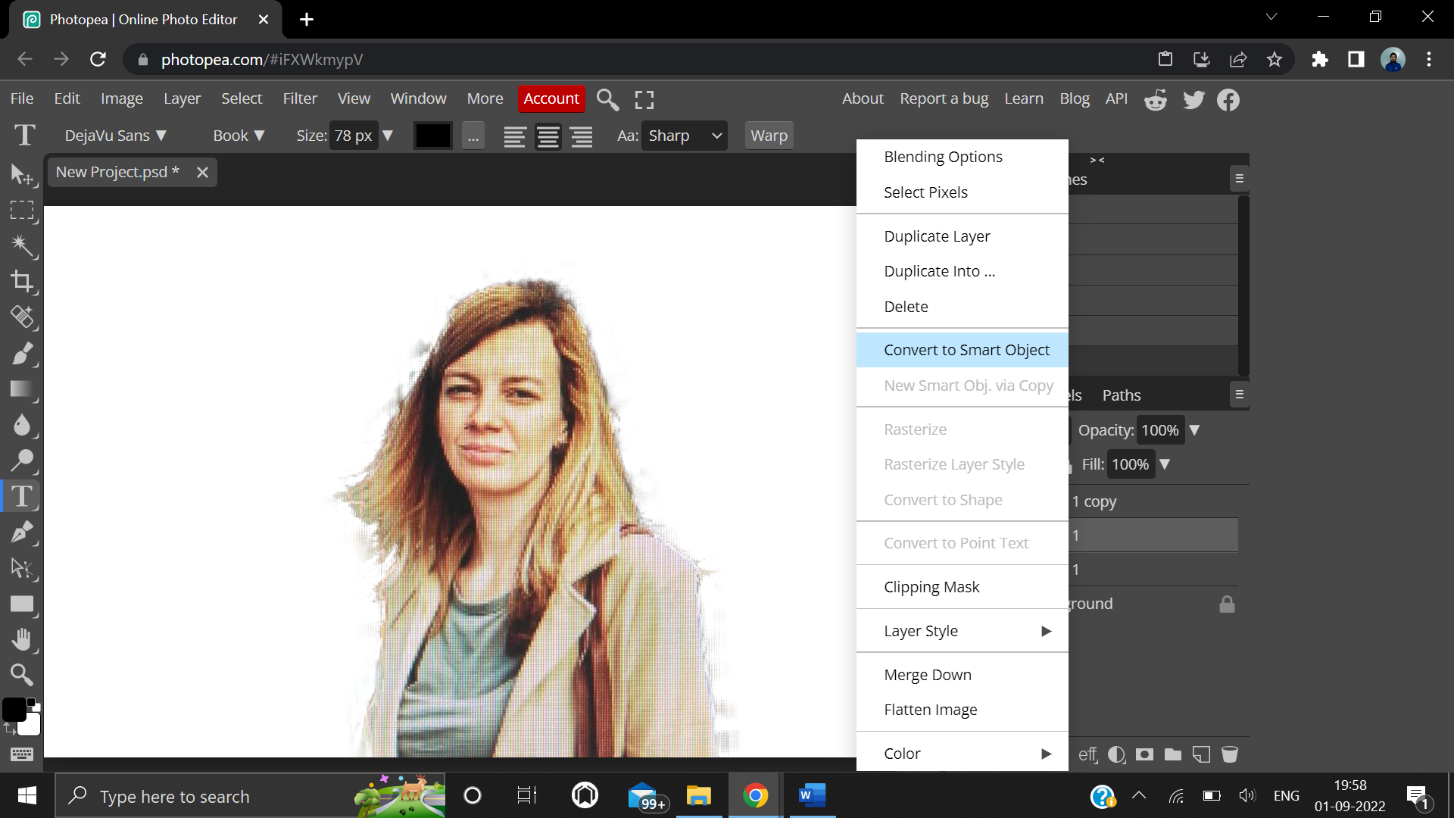

**Step 6:** Again right click on that layer from the layer menu, and add a new hue and saturation adjustment layer from the dropdown.

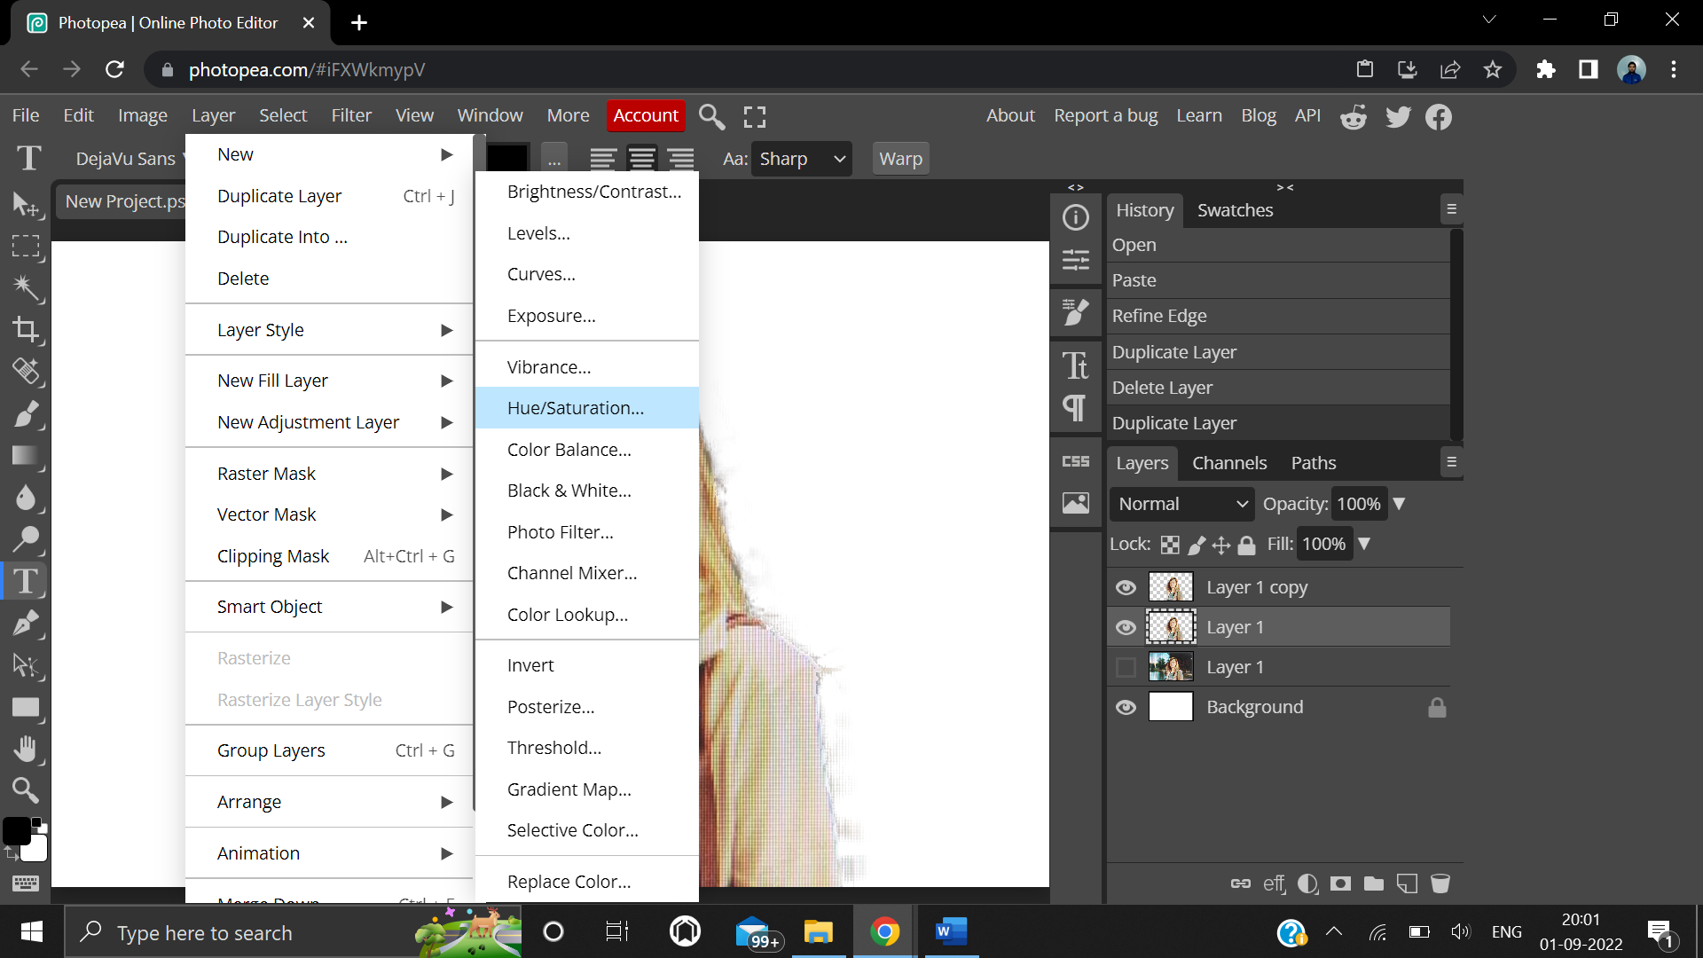

**Step 7:** Make the saturation -100 to remove colors from the image.

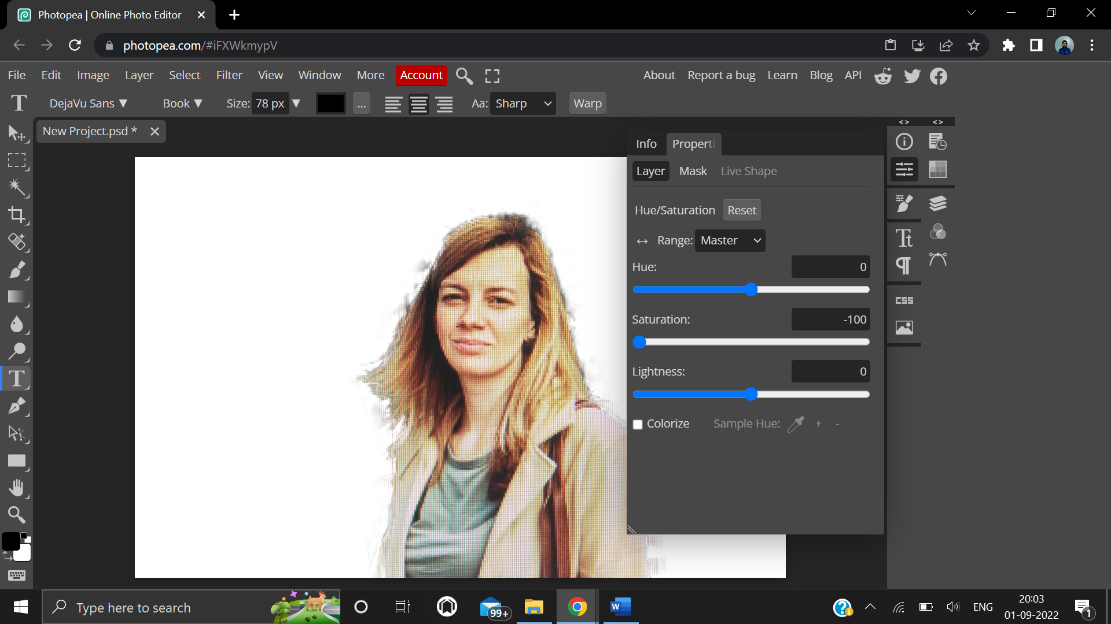

**Step 8:** Then, invert the image by pressing Ctrl + I on the keyboard and change the blending mode of the duplicate layer to color dodge from the layer menu.

**Step 9:** From the filter menu on the top navbar, add a Gaussian Blur filter.

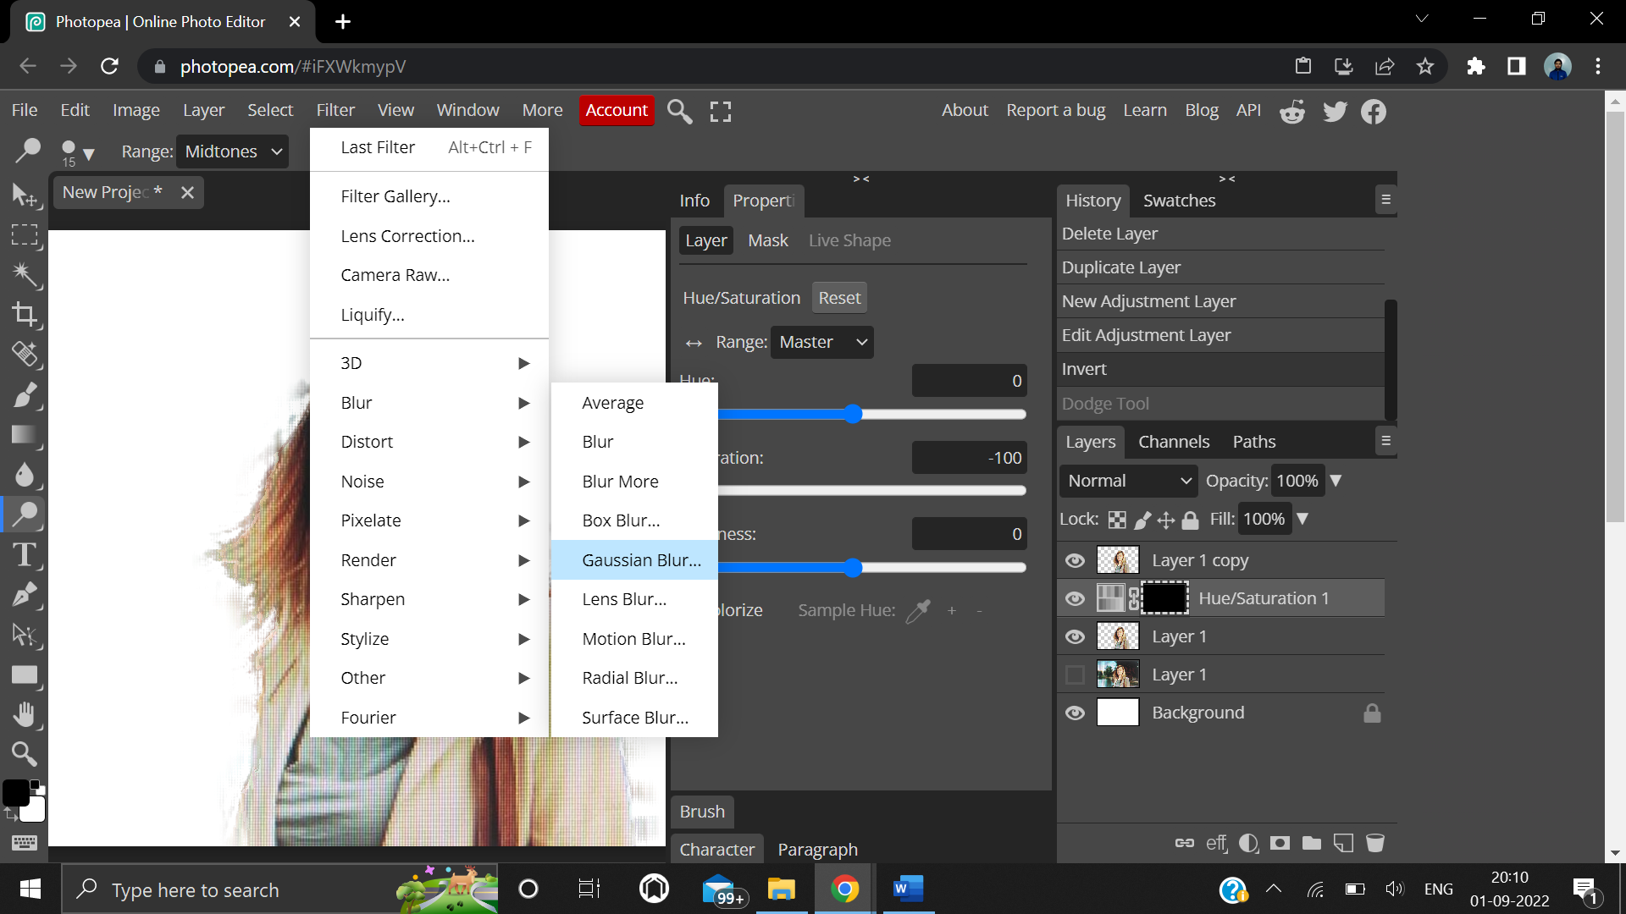

**Step 10:** Finally, add contrast to the image by adding a curves adjustment layer.

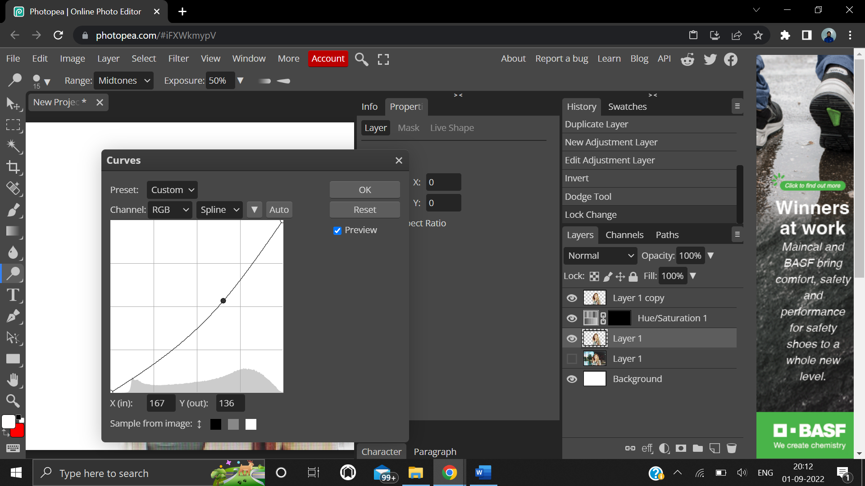

**4. Result/Output/Writing Summary:**

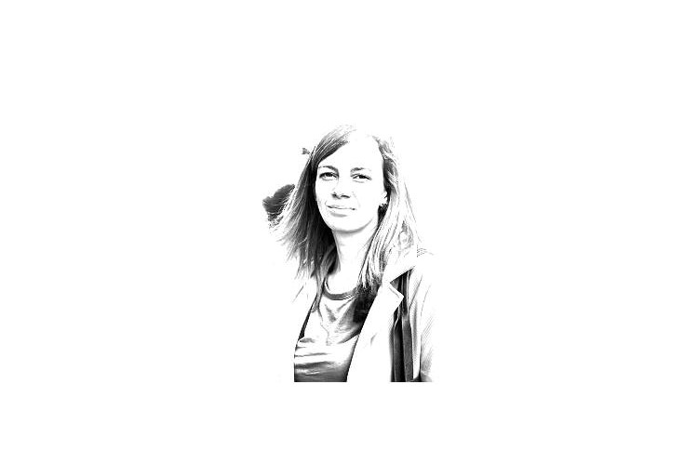

**Pencil Sketch**

**Learning outcomes (What I have learnt):**

**1.** Learnt how to remove background from a photo using Magic Cut tool on Photopea.

**2.** Learnt about many different effects that can be added to images for different purposes.

**3.** Learnt how to make a real life image look like a pencil sketch by adding certain effects on Photopea.

**4.** Learnt how to convert image into smart object.

**5.** Learnt how to invert the image and how to adjust the saturation level of image.

**Evaluation Grid (To be created as per the SOP and Assessment guidelines by the faculty):**

|  |  |  |  |
| --- | --- | --- | --- |
| Sr. No. | Parameters | Marks Obtained | Maximum Marks |
| 1. |  |  |  |
| 2. |  |  |  |
| 3. |  |  |  |
|  |  |  |  |